Steps for Initial HSRB Application Submission via Etrieve

- Review the HSRB website to confirm that you have all the documentation needed for your submission.
  - It may be helpful to use the Word document (link on website) to type out your application that you can then copy and paste into the Etrieve form
  - All supplemental documentation should be in PDF format.

- Once ready to fill out the Initial HSRB Application, you will click on the application button on our website (or get into Etrieve via the RWU Etrieve link):

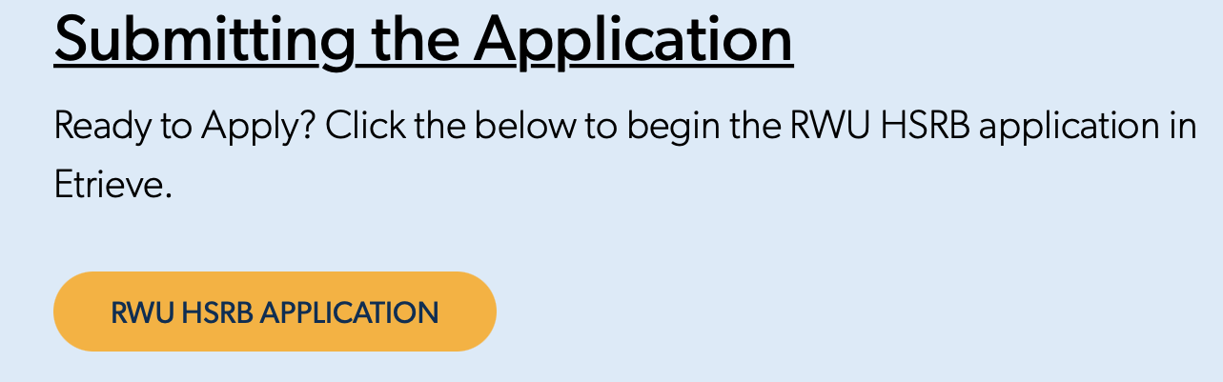

- This will take you to the Etrieve portal. You will not log in on this page but rather click the icon:

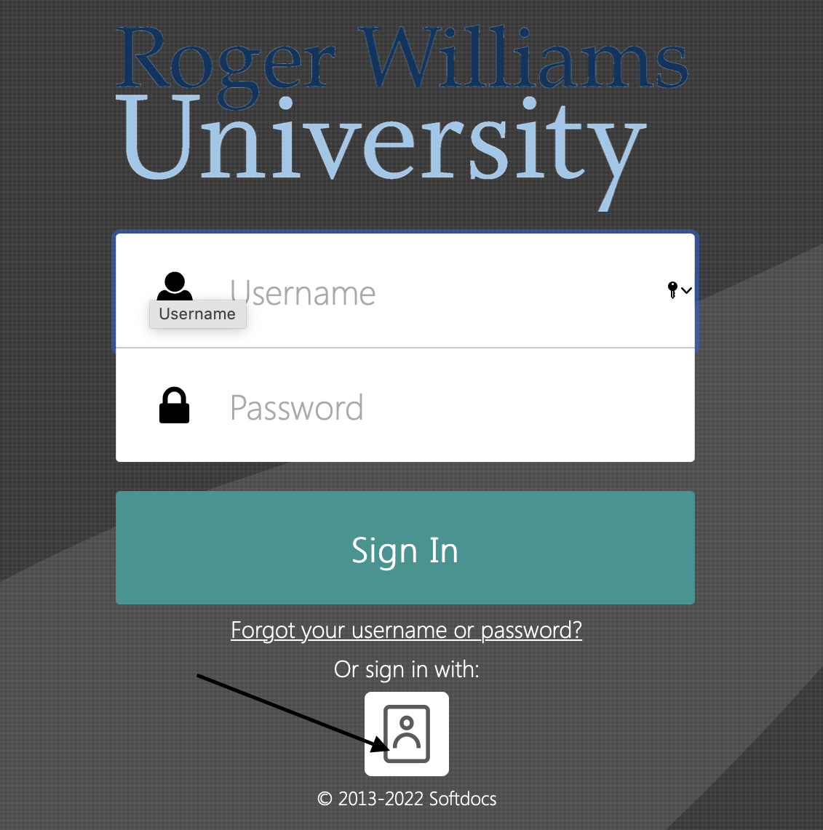

- This will take you to the log in page for RWU Etrieve. You will enter your username and password here and this will take you into Etrieve.
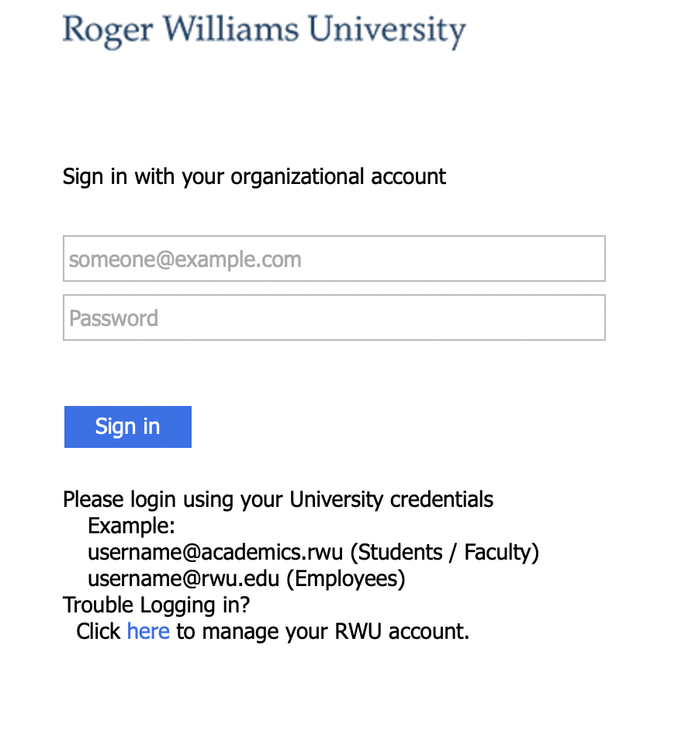
- You will then select “Forms”:

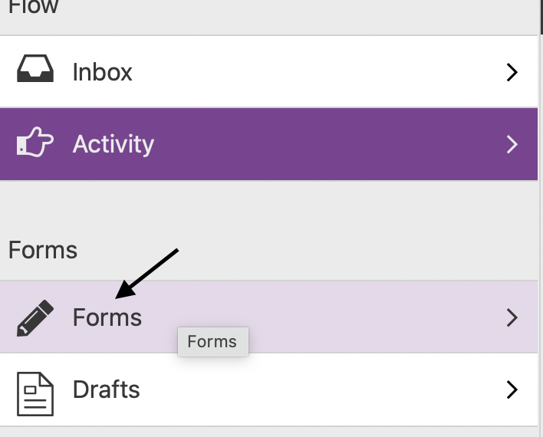

- And then click on HSRB application under the Research Tab:
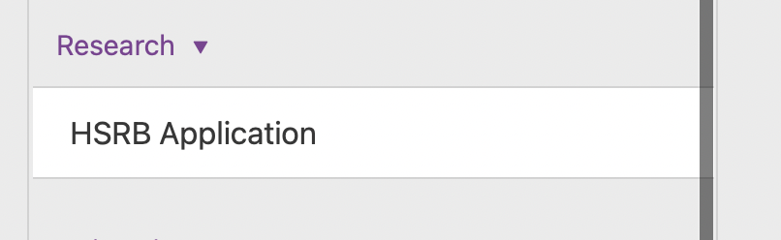

- This will generate the HSRB Application form. The form comes pre-populated with your name and some contact information.
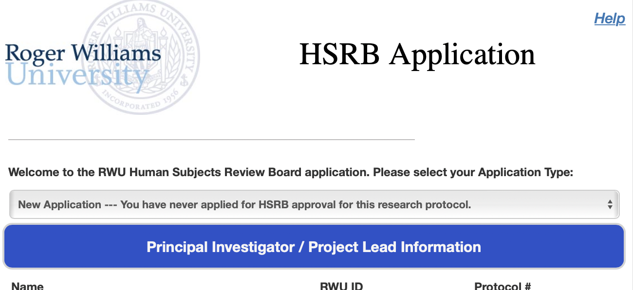

- If you are a student, your information will also be pre-populated, and you will be asked to provide your faculty PI information (don’t forget you will need to attach a letter of support!)

- You will be asked to provide the same information that was previously part of the Qualtrics application.
  - Some buttons ask you to check what is relevant to your study. These may expand to obtain more information
  - There are also fields in which you can directly type (or copy from a word document). If these are required, this will be noted.
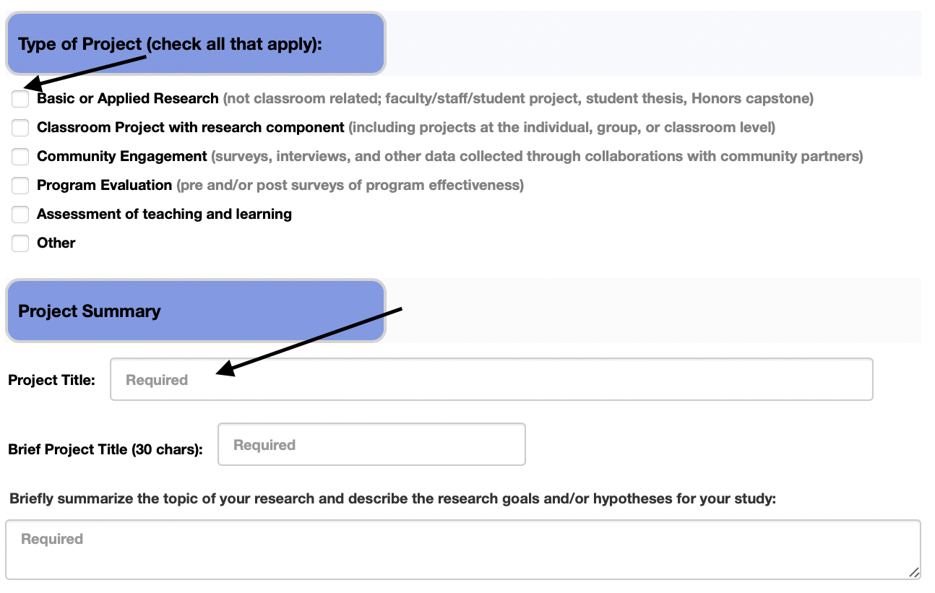
- Once you have completed all the fields, you will be asked to check off all of the forms that you will submit as supplemental materials for your application. Please select all that apply.
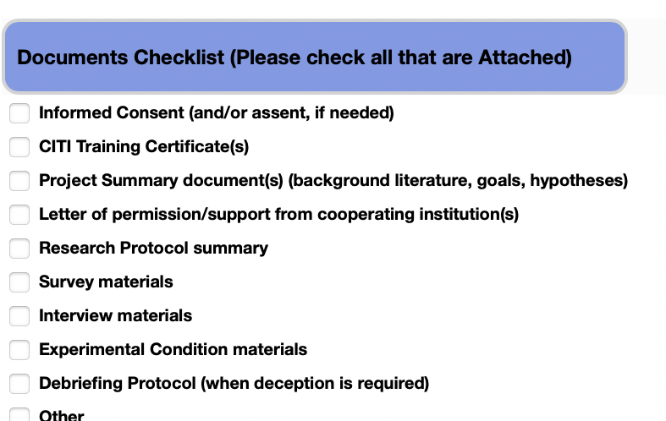

- Please submit all supplemental materials using the attachment button.


You will be able to submit multiple documents from your computer. These documents should be in PDF format.
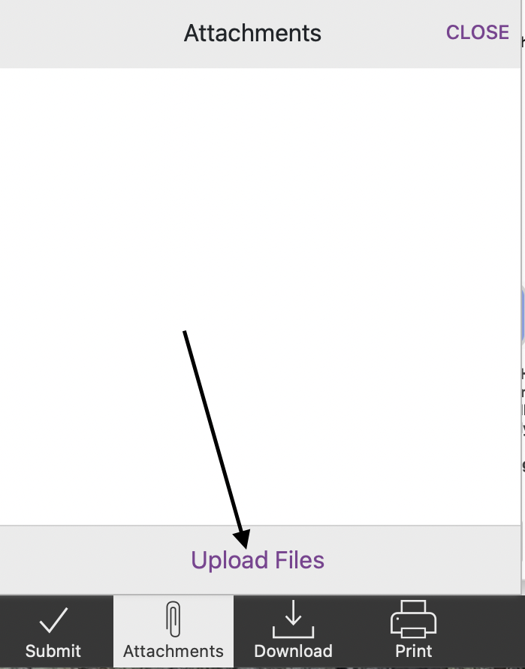

- Once this is complete. You will be prompted to sign the statement of ethics and the submission certification.

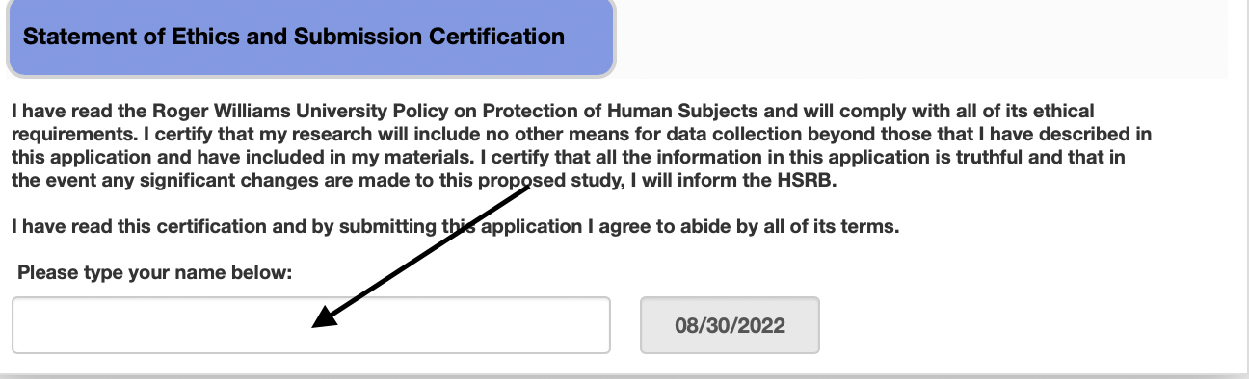

- You can now press submit. If you have not checked all of the required boxes, the Etrieve system will alert you to the question that needs to be answered. Once complete, the system will allow you to submit.



- Once submitted, HSRB will begin our review process. If we have any questions, we will use the Etrieve system to ask and you can provide clarification, upload new documents, and respond to questions from the board.
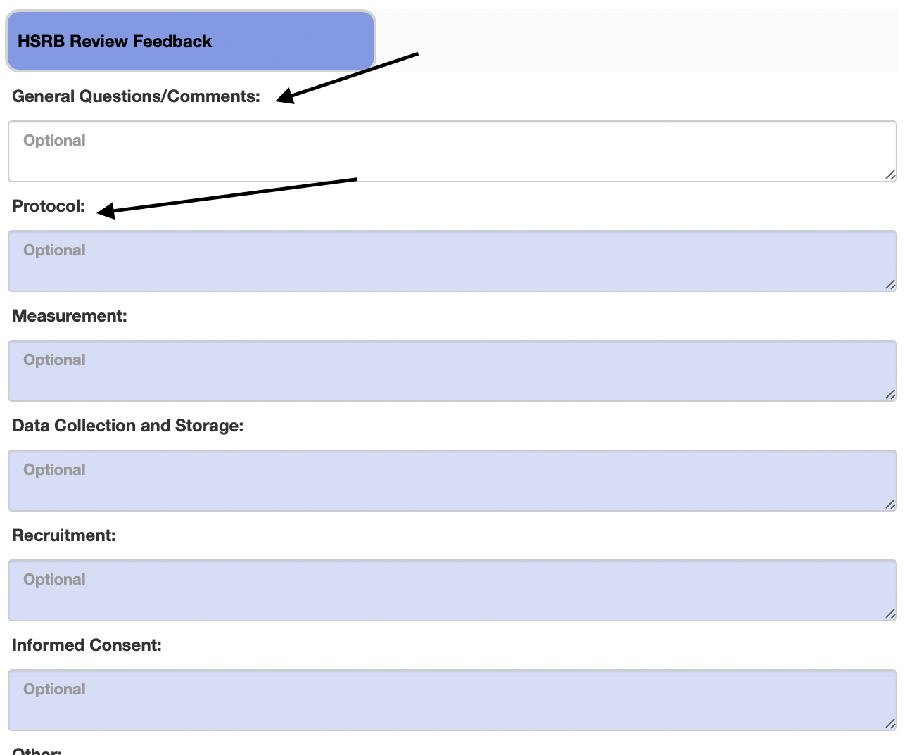

- Once submitted, you can see where your submission is in the HSRB process by clicking on the History tab.


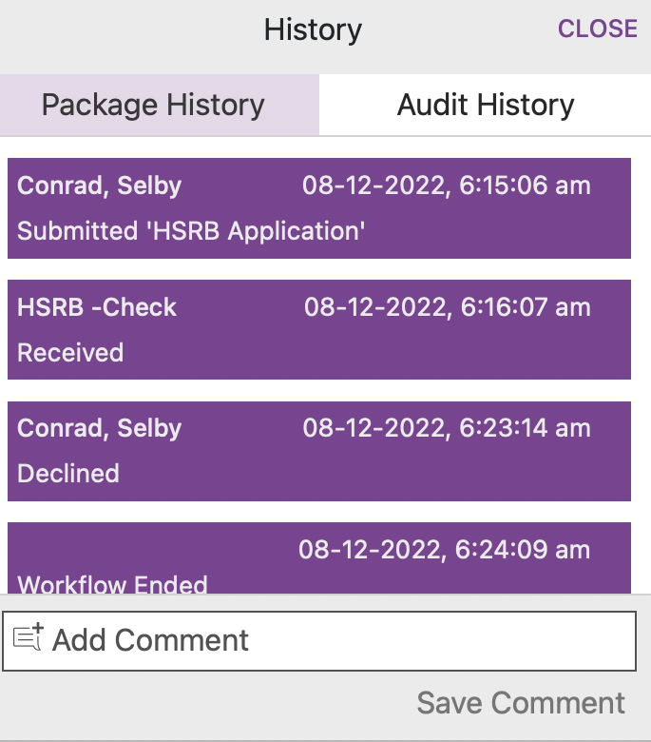
- Once approved (or if you chose to withdraw your application), you will be asked to sign a certification. You will receive an email notification in your RWU email (or the email that you used in the application), indicating that you need to sign this document. If your study is approved, this will be your approval letter.
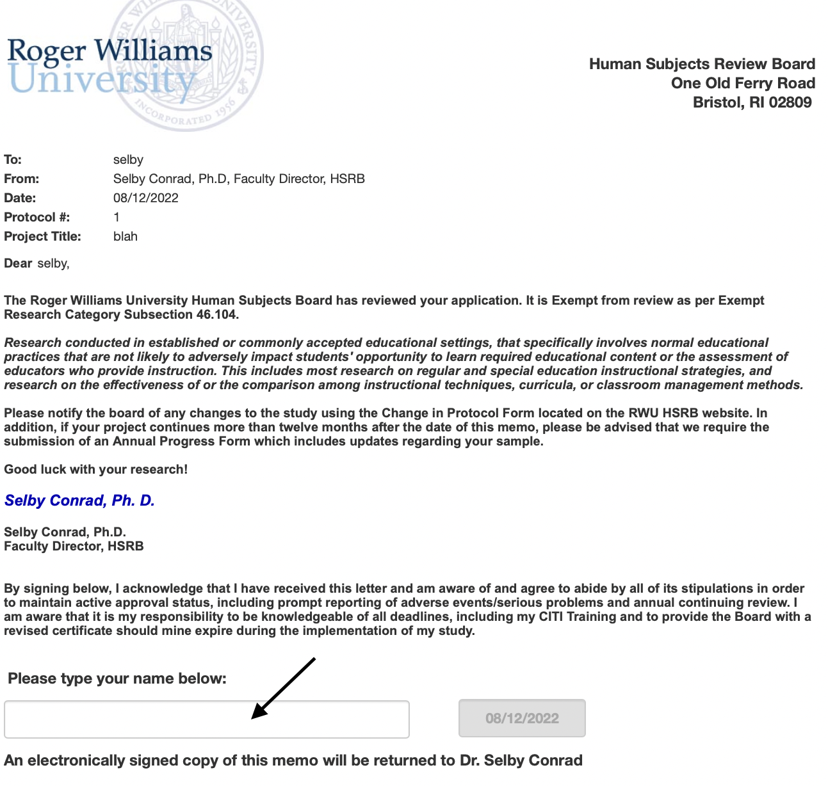

- You will receive a final email to your RWU email closing the application and indicating that your approval status.

Other important features of the new application.

- You can download your application or print using the buttons at the bottom of the screen. This will be true at each stage of submission so once approved you can download and/or print the documents associated with the project – including the approval letter.


If you need a copy of your approval letter, you can get this document
via this process.

- All your submitted packages will be available by clicking the Activity tab. If you are a faculty member supervising research, you will be able to see all of these packages.

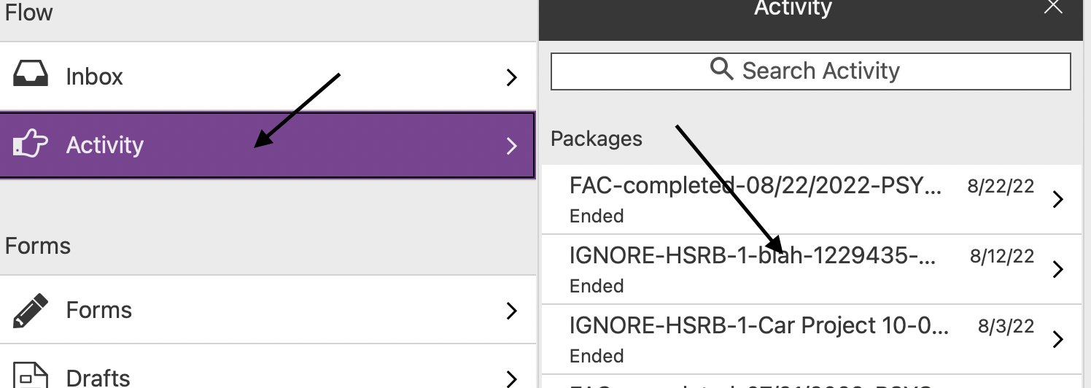

Thank you for taking the time to read this document. Please don’t hesitate to outreach to us with any questions that you have!

