Don’t Let Your Spring Break Be a Flop!

Public Safety & Money Tips
- Plan to take emergency money for unexpected problems.
- Confirm reservations before leaving town and let someone know how and where to reach you.
- Make two copies of your passport, airline tickets, driver’s license and credit cards. Leave a copy with a friend and bring a copy with you in case the originals get misplaced or stolen.
- Call your credit card company to let them know you will be out of town to prevent against them placing a hold for suspicious activity.
- Avoid handbags, these are easy to steal. Put your money in multiple places on you.
- When in a group stay with each other. Don’t stray.

Sun Safety Tips
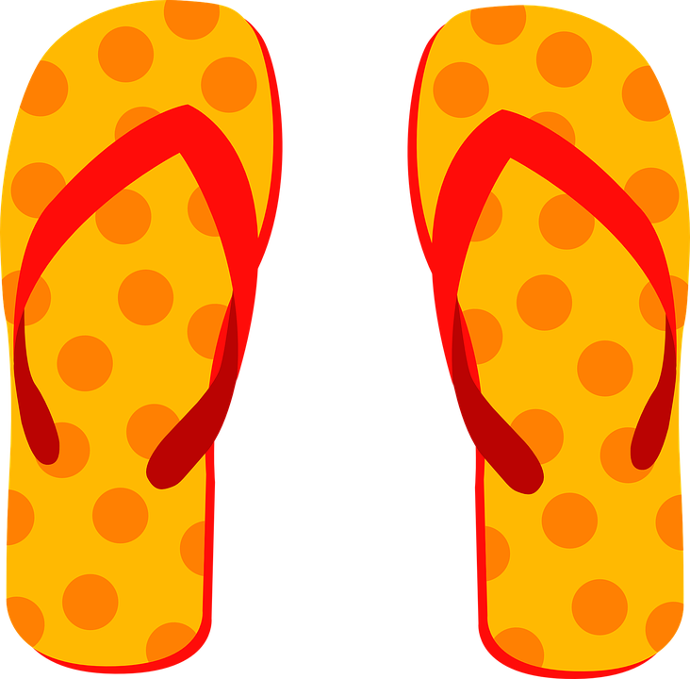
- Wear sunscreen and reapply every two hours. Use SPF 15 or higher, even when it’s cloudy.
- Apply sunscreen to dry skin 15 to 30 minutes before going outdoors.
- Drink a lot of water to remain hydrated. (1/2 of your body weight in ounces)
- Wear sunglasses with UV lenses.

Drinking Safety Tips
- Alternate drinks with water.
- No more than one drink an hour, no more than five drinks in a sitting.
- Eat a meal before you go out drinking.
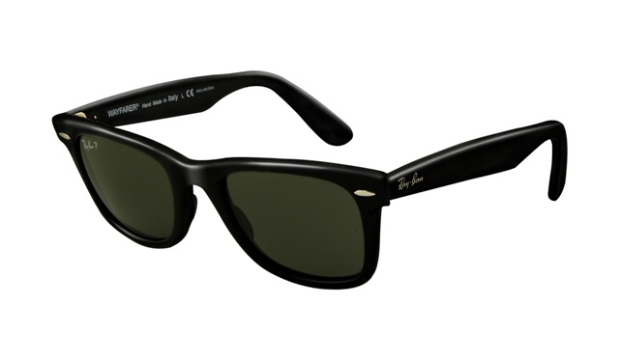
- Avoid drinking games, know your limit.
- Know the signs of alcohol poisoning and get help if needed.

Sex Safety Tips
- Be in control. Alcohol and other drugs affect good judgment and self-control. Sober sex is the best sex.
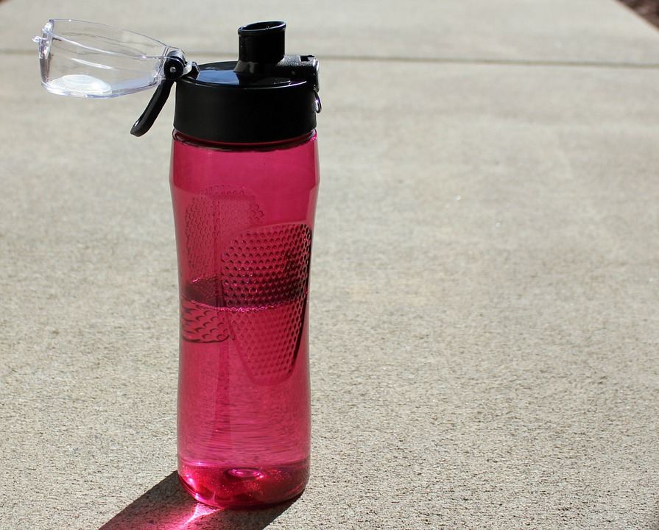
- Protect yourself, always wear a condom. NO condom, NO sex!

Rape Awareness Tips
- Use the buddy system. Pair up with a friend and keep tabs on each other.
- In 1 out of 3 sexual assaults, the perpetrator and victim were intoxicated
- Speak up if you are uncomfortable. Only you should make decisions about your body.
- Don’t accept drinks from strangers, don’t leave drinks unattended.



